

# A CRM APPLICATION ON E- COMMERCE ACTIVITIES

**PROJECT REPORT**

***Submitted By***

**KAVIYA G(611420205020)**

**ANITHA S(611420205003)**

**BABYSHALINI G(611420205005)**

**SELINSHEEBHA E(611420205036)**

***in partial fulfilment for the award of the***  ***degree of***

**BACHELOR OF TECHNOLOGY**

***in***

## Information technology

**MAHENDRA ENGINEERING COLLEGE FOR WOMEN**

**Namakkal-637205**

**BONAFIDE CERTIFICATE**

Certified that this project report titled **“CRM APPLICATION ON ECOMMERCE ACTIVITIES ”** is the Bonafide work of **“KAVIYA G**

**(611420205020), SELINSHEEBHA E**

**(611420205036), ANITHA S (611420205003), BABYSHALINI G**

**(611420205005)”** who carried out the project work under my supervision.

**SIGNATURE SIGNATURE**

Dr.N.RATHIKA,M.E.,Ph.D., Mr.K.A.KARTHICK,M.E., **HEAD OF THE DEPARTMENT FACULTY MENTOR**

**PROFESSOR ASSISTANT PROFESSOR**  Department of information Department of information technology technology

Mahendra engineering college for women , Mahendra engineering college for women,

Kumaramangalam, Kumaramangalam

Namakkal-637205 Namakkal637205

---------------------------------------------------- ------------------------------------------------------------

**SPOC HEAD OF THE DEPARTMENT**

## ACKNOWLEDGEMENT

At the outset, we express our heartfelt gratitude to **GOD,** who has been our strength to bring this project to light.

At this pleasing moment of having successfully completed our project, we wish to convey our sincere thanks and gratitude to our belovedpresident SHRI.M.G.BHARATHKUMAR,M.A,.B.Ed,who has provided all the facilities to us. We would like to convey our sincere thanks to our beloved Principal **Dr.B.DORA ARULSELVI,B.E,.M.E.,Phd.,**for

forwarding us to do our project and offering adequate duration in completing our project.

We express our sincere thanks to our Head of the Department **Dr.,N.RATHIKA,M.E.,Phd.,** Department of information technology the excellent academic climate in the Department.

We express our pronounced sense of thanks with deepest respect and gratitude to our Faculty Mentor **Mr.K.A.KARTHICK,M.E.,**

Department of Information technology for their valuable and precious guidance and for having amicable relation. Department of Information technology for their valuable and precious guidance With deep sense of gratitude, we extend our earnest and sincere

thanks to our SPOC Faculty:**M.Manimegalai**.,M.E.,Head of the Department,ECE. Assistant Professor, Department for his guidance and encouragement

during this project. We would also like express our thanks to all the faculty members of our department, friends and students who helped us directly and indirectly in all aspects of the project work to get completed successfully.

## TABLE OF CONTENTS

|  |  |  |
| --- | --- | --- |
| **CHAPTER**  **NO.** | **TITLE** | **PAGE**  **NO.** |
| **1** | **INTRODUCTION** |  |
| **2** | **PROJECT SPECIFICATIONS** |  |
|  | 2.1 Project Goal |  |
|  | 2.2 Project Scope |  |
|  | 2.3 Technical Requirements |  |
|  | 2.4 Functional Requirements |  |
| **3** | **PREPARATION DATA MODELING** |  |
| **4** | **USERS & DATA SECURITY** |  |
| **5** | **AUTOMATION** |  |
| **6** | **REPORTS & DASHBOARD** |  |
|  | GitHub & Project Video Demo Link |  |

# 1.INTRODUCTION

Salesforce, a leading cloud-based Customer Relationship Management (CRM) platform, is a pivotal tool for organizations to manage customer data, optimize sales processes, and elevate customer interactions. Its multifaceted features include Sales Cloud, which enhances sales management through lead tracking, opportunity management, and seamless email integration. Service Cloud focuses on exceptional customer support, featuring case management, knowledge base development, and multi-channel support. Marketing Cloud empowers businesses with marketing automation, email campaigns, social media engagement, and in-depth analytics. Salesforce's hallmark is its customizability, allowing businesses to tailor the platform to meet specific requirements, while robust integration capabilities facilitate seamless connections with other business applications.

The platform equips businesses with powerful reporting and analytics tools, enabling data-driven decisions and insightful, customized reports and dashboards. Salesforce ensures mobile accessibility, enabling users to stay connected and productive while on the move. A paramount emphasis on data security and compliance guarantees data protection and privacy. Whether you're a small startup or a large enterprise, Salesforce offers scalability to accommodate your evolving needs.

Through Salesforce, organizations foster improved customer relationships, increased sales efficiency, and superior customer support. It empowers businesses to make data-driven decisions, streamline operations, and create impactful, targeted marketing campaigns. This introduction encapsulates Salesforce's capabilities and benefits, offering a concise overview for your project document, allowing for a better understanding of how the platform can contribute to your specific project goals.

# 2.PROJECT SPECIFICATIONS

**2.1 Project Goal** A CRM (Customer Relationship Management) application integrated into Salesforce, specifically designed to facilitate the booking of visa slots, can greatly streamline the operations of travel and visa processing companies.The primary goal of a CRM application designed to help book visa slots is to enhance the efficiency and effectiveness of the visa application process Simplify and expedite the visa slot booking process for applicants, making it easy for them to select suitable time slots based on their preferences. Provide real-time information on slot availability across various consulates and embassies, ensuring applicants have up-to-date access to available appointments.

## 2.2 Project Scope

* **Creation of Developer Account (Milestone 1):** To create a developer account for the Visa Slot Booking CRM application, visit the platform's website, select "Developer Account," and follow the registration process by providing essential information.
* **Object Creation (Milestone 2):** In the CRM application, object creation involves defining data structures for key elements like "Visa Applications" or "Appointments" to organize and manage essential booking and application information.
* **Tabs Creation (Milestone 3):** Tabs in the CRM application offer quick access to essential features, such as "Appointments," "Payments," and "Support," streamlining navigation for efficient visa slot booking and management.
* **Relationship Between Objects (Milestone 4):** Relations between objects in the CRM application link data, enabling connections like "Visa Applications" to "Applicants," ensuring seamless tracking of applicants' visa-related information and interactions
* **Field Creation (Milestone 5):** Field creation in the CRM application involves defining data attributes like "Appointment Date" or "Payment Status" to store and manage crucial information for visa slot booking and processing.
* **Apps (Milestone 6):** In the CRM application, "APPS" refers to the software's mobile applications, allowing users to access and manage visa slot booking and related tasks on their mobile devices for convenience**.**.
* **Users (Milestone 7):** In the CRM application, a "User" refers to individuals who interact with the system, including applicants booking visa slots and administrative staff managing the process..
* **User Adoption (Milestone 8):** "User adoption" in the CRM application refers to the degree to which individuals successfully integrate and regularly use the system for booking visa slots, indicating its effectiveness..
* **What are Reports? (Milestone 9):** Reports are data summaries in the CRM application, presenting key insights into visa slot booking processes, helping administrators analyze trends and performance.
* **Dashboards (Milestone 10):** Dashboards in the CRM application are visual data displays, providing at-a-glance insights on visa slot booking metrics, enhancing decisionmaking and operational efficiency.
* In summary, the CRM application for visa slot booking streamlines the entire process. It efficiently manages user data, from the creation of objects and fields to the use of tabs for navigation. The relationship between objects ensures seamless tracking, while reports and dashboards offer essential insights. User adoption and mobile apps enhance accessibility, making this CRM system a comprehensive solution for efficient and userfriendly visa slot booking and management.

## 2.3 Technical Requirements

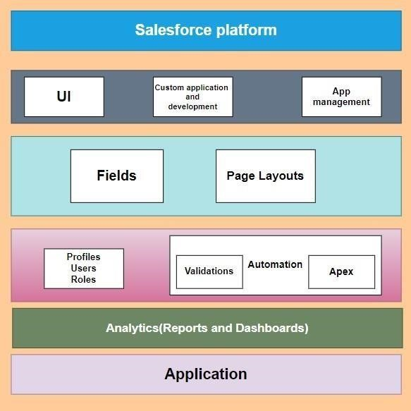

## 2.4 Functional Requirements

* **User Registration:** Users can create accounts with personal information for access to visa slot booking.

* **Login and Authentication:** Secure login mechanisms with password protection and multi-factor authentication.

* **Real-Time Slot Availability:** Constantly updated slot availability information from consulates and embassies.

* **Booking Slots**: Users can select and reserve visa appointment slots based on preferences.

* **Automated Notifications:** Automated email and SMS notifications for appointment confirmations, reminders, and updates.

* **Document Upload:** Capability to upload, view, and manage visa application documents.

* **Payment Integration:** Integration with secure payment gateways for online payment of visa fees.

* **User Profile Management:** Users can update and maintain their profiles with ease.

* **Slot Cancellation and Rescheduling:** Users can cancel and reschedule appointments as needed.

* **Reporting and Analytics:** Creation of comprehensive reports and data analytics for performance evaluation.

* **Admin Dashboard:** An admin panel to manage users, appointments, and system settings.
* **Integrated Support Chat:** A live chat system for real-time user assistance and issue resolution.

* **Data Security Measures:** Implementation of robust data encryption and security features.

* **Compliance with Data Protection Regulations:** Ensuring adherence to data privacy laws and regulations.

* **Efficient Slot Allocation:** Allocation of slots without overbooking or underutilizing consulate resources.

* **User Feedback Gathering:** Collection of user feedback and reviews for continuous improvement.

* **Multi-Language Support:** Support for multiple languages to cater to a diverse user base.

* **Support Ticket System:** A ticketing system for users to log and track support requests.

* **Payment Status Tracking:** Users can track the status of their payment for visa application fees.

* **User Training Materials:** Availability of training materials and user guides for effective usage.

* **Customizable Data Fields:** The ability to customize and add data fields to capture specific information.

* **Audit Trail Logging:** A record of all actions and changes for transparency and accountability.

* **User Notifications:** Email or SMS notifications to keep users informed about visa application status.

# 3.PREPARATION DATA MODELING

**Objects:**

Objects are database tables that permit you to store data that is specific to an organization. Salesforce objects are of two types:

1. Standard objects.
2. Custom objects.

|  |  |  |  |
| --- | --- | --- | --- |
| **Object** | **Passport** | **Visa Slot** | **Payment** |
| **Fields** | Full Name  (Text) | Location  (Text) | Payment Mode  (Picklist) |
| **Fields** | Contact Number  (Number) | Time  (Data&Time) | CardNumber  (Number) |
| **Fields** | PassportNumber  (Text) | Visa Slot Number  (Auto Number) | Transaction ID  (Auto Number) |
| **Fields** | Permanent address  (Text area) | Passport number  (Master details) | Visa Slot Number  (Master details) |
| **Fields** |  | Status(Picklist) | Cancel  Transaction  (Check Box) |

**1)Creation 0f Custom Object Passport:**

For this Book My Visa Slot we need to create 3 objects

Passport, Visa Slot and

Payment. The below steps will assist you in creating those objects.

1. Click on the gear icon and then select Setup
2. Click on the object manager tab just beside the home tab

After the above steps, have a look on the extreme right you will find a Create Dropdown click on that and select Custom Object

1. On the Custom Object Definition page, create the object as follows:
2. Label: Passport
3. Plural Label: Passports
4. Record Name: Passport Number
5. Check the Allow Reports checkbox
6. Check the Allow Search checkbox
7. Click Save.

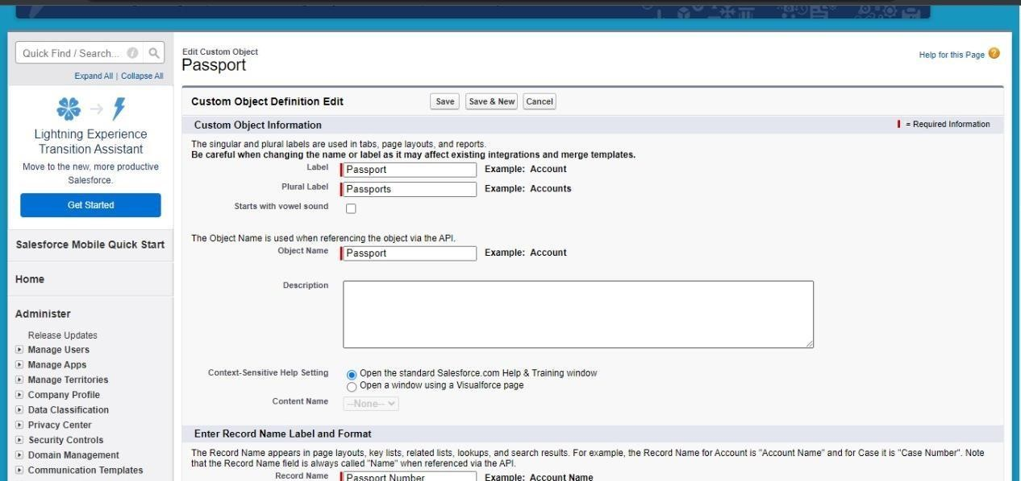

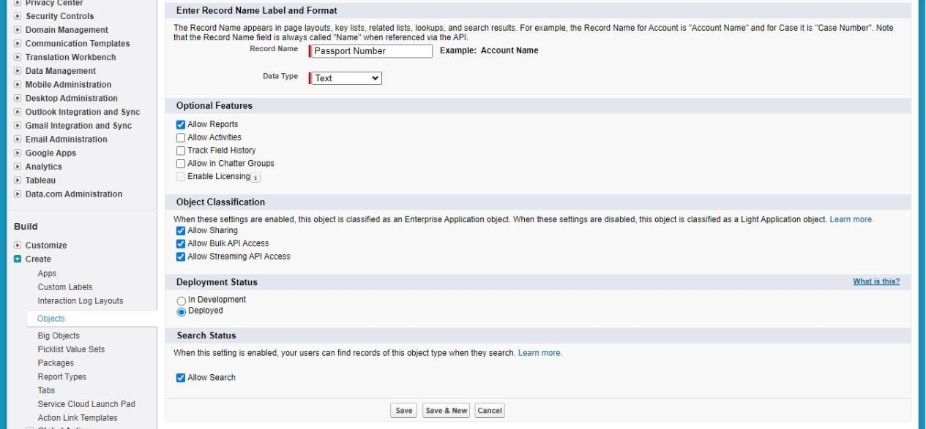

**2)Creation Of Custom Object-Visa Slot:**

1. Click on the gear icon and then select Setup.
2. Click on the object manager tab just beside the home tab.
3. After the above steps, have a look on the extreme right you will find a Create Drop down click on that and select Custom Object

On the Custom Object Definition page, create the object as follows:

1. Label: Visa Slot
2. Plural Label: Visa Slots

6.Record Name: Visa Slot Number(Auto Number)

7.Check the Allow Reports checkbox

8.Check the Allow Search checkbox,Click Save.

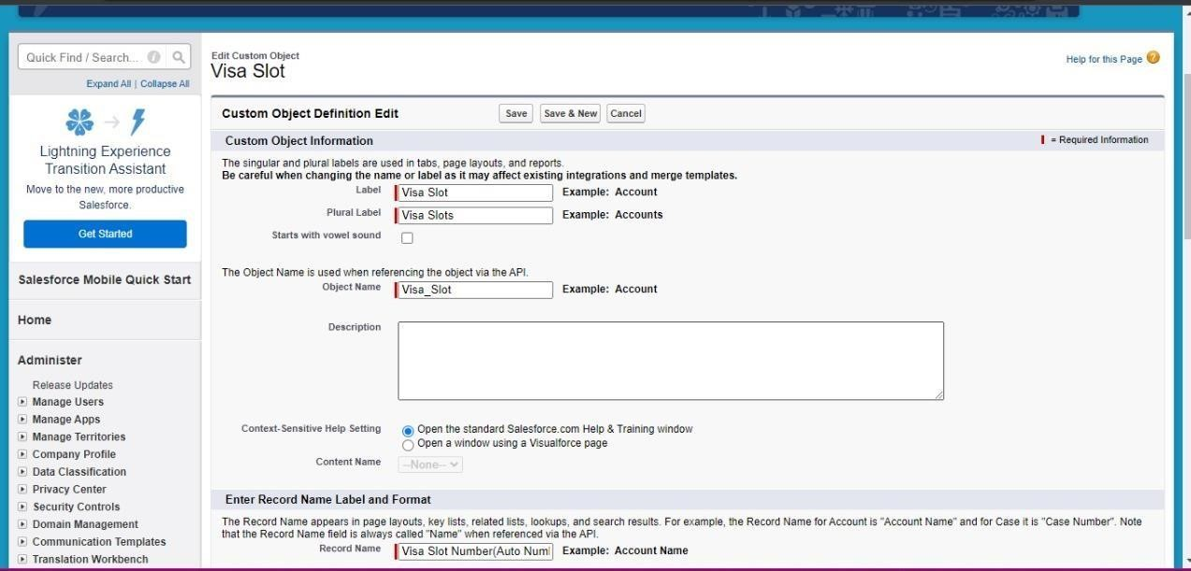

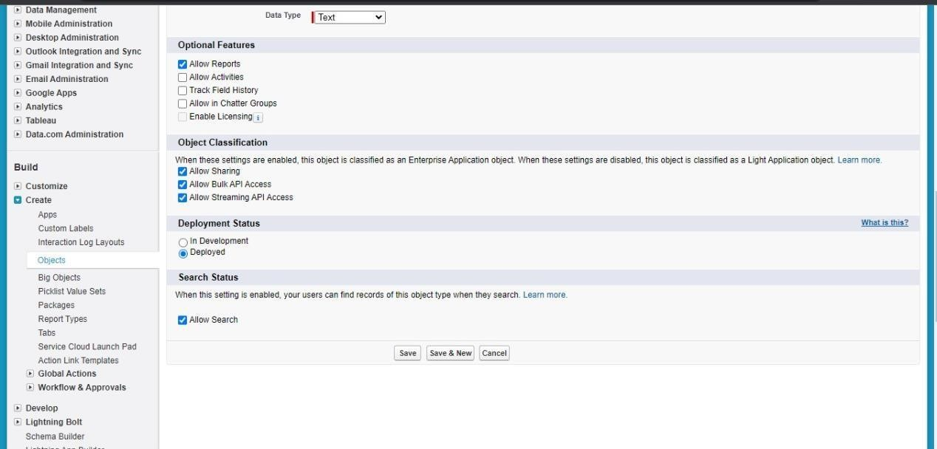

**3)Create Of Custom Object- Payment:**

1. Click on the gear icon and then select Setup.
2. Click on the object manager tab just beside the home tab.
3. After the above steps, have a look on the extreme right you will find a Create Drop down click on that and select Custom Object.

4.On the Custom Object Definition page, create the object as follows:

5.Label: Payment

6.Plural Label: Payments

7.Record Name: Transaction Id (Auto Number)

8.Check the Allow Reports check box

9.Check the Allow Search check box

10.Click Save.

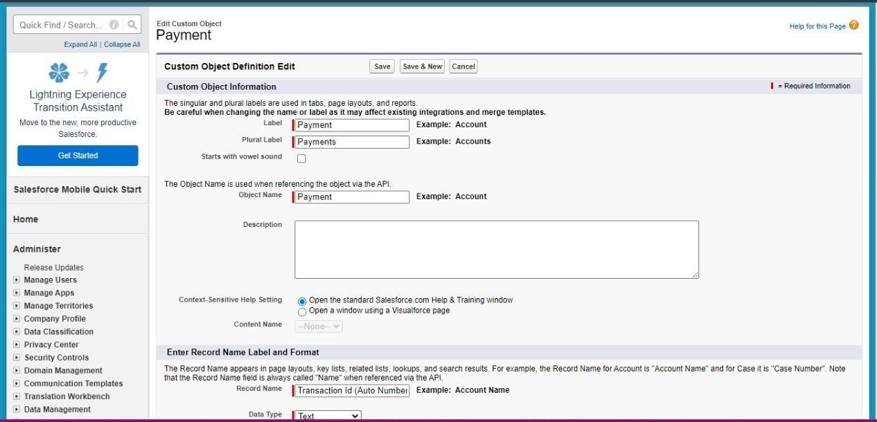

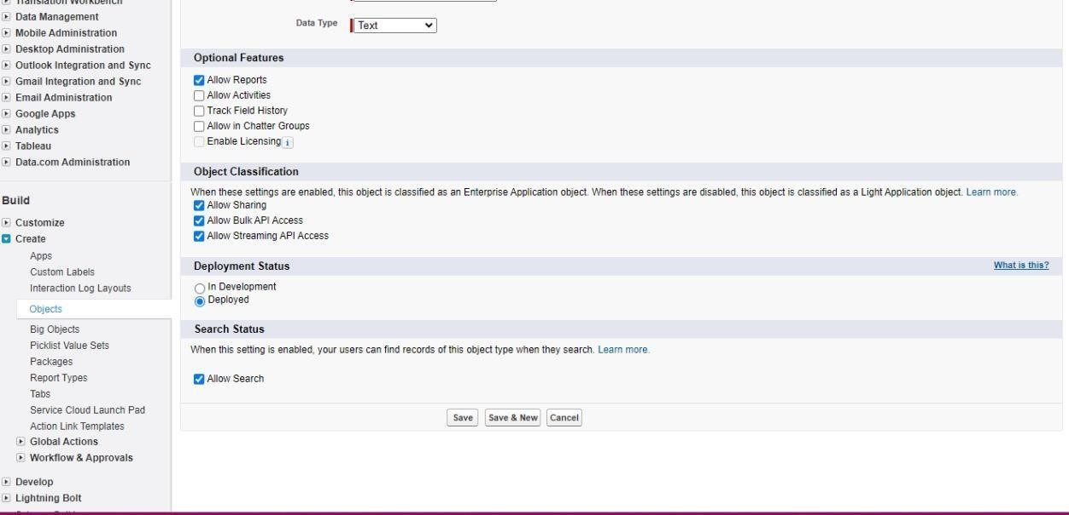

**Tabs:**

**Tab:** A tab is like a user interface that used to build records for objects and to view the records in the objects. Tabs basically categorize into 4 different sections1.

1.Standard Object Tabs

1. Custom Object Tabs
2. Web Tabs
3. Visualforce Tabs

**1)Creation of Custom Tab- Passport Object:**

Navigate to setup and home

1. Enter Tabs in Quick Find Box and select Tabs
2. Under Custom Object Tabs, click New
3. For Object, select Passport
4. For Tab Style, select any icon
5. Leave all defaults as is. Click Next, Next, and Save

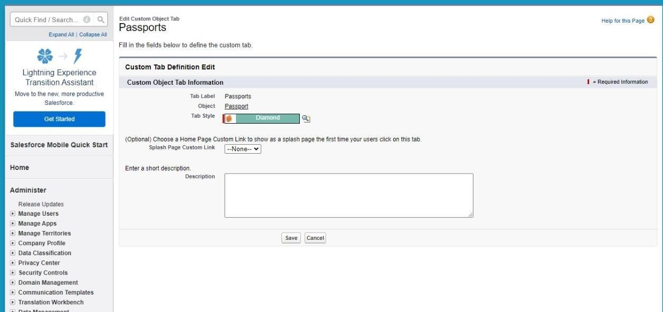

**2)Creation Of Custom Tab- Visa Slot Object:**

Navigate to setup and enter Tabs in Quick Find and select Tabs. Under Custom Object Tabs, click New.

1. For Object, select Visa Slot.
2. For Tab Style, select any icon.
3. Leave all defaults as is. Click Next, Next, and Save.

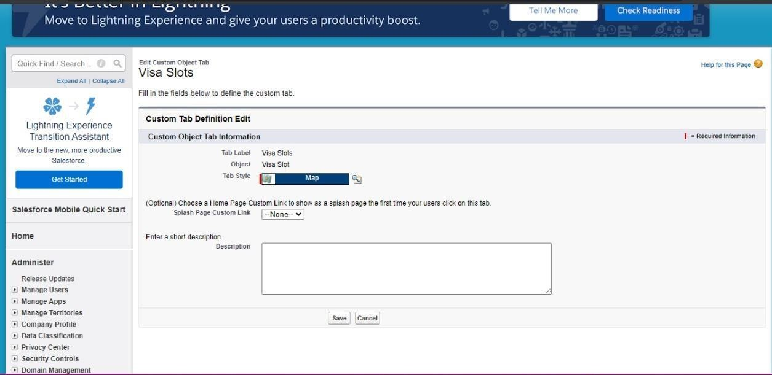

**3)Creation Of Custom Tab- Payment Object**

Navigate to setup and enter Tabs in Quick Find and select Tabs Under

Custom Object Tabs, click New

1. For Object, select Payment
2. For Tab Style, select any icon
3. Leave all defaults as is. Click Next, Next, and Save

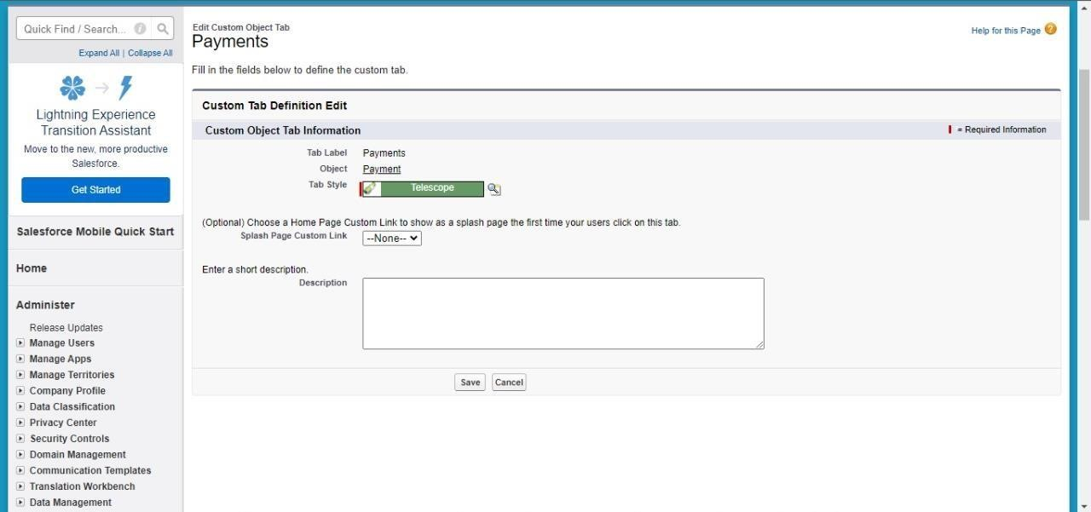

**Relationship B/W Objects:**

Relationship in Salesforce is a 2-way association between 2 objects. Using relationships, we can link objects with each other and we can make connections and display data about other related objects. Primarily there are two types of relationships:

1. Master detail relationship: A master-detail relationship defines the relationship between the parent and the child. The master table defines the parent relation and the detail defines the child relation. If the master table is deleted then the child record data is also deleted
2. Look up relationship: Lookup Relationship in Salesforce links two objects together but has no effect on deletion or security.

To Create a Master-Detail relationship between Passport and Visa Slot Objects.

**1)Relationship Creation:**

Fields Creation: Passport Number

Navigate to setup

1. Click on Object Manager and search and select Visa Slot object
2. Select Fields & Relations and click New.
3. Select Data Type: Master-Detail, next.
4. Related to: Passport, next.
5. Label: Passport Number
6. Child Relationship Name: Visa Slot, next.
7. Next, next and save.

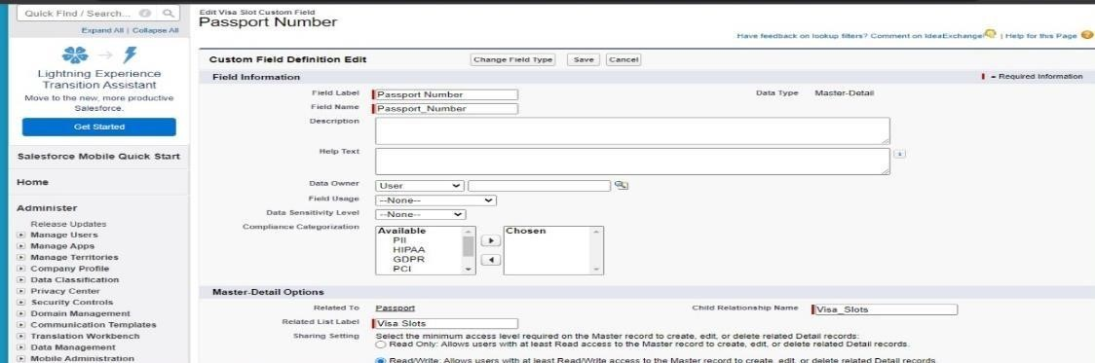

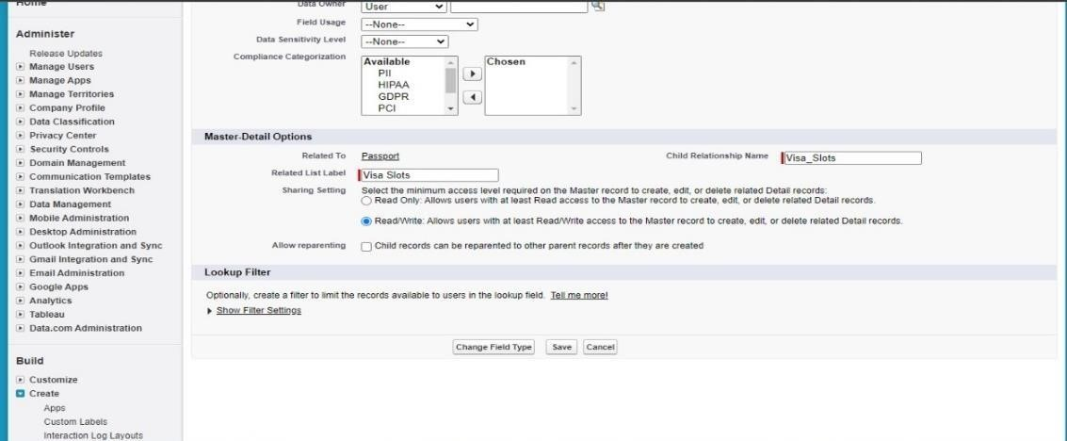

**Field Creation:**

This milestone explains about Field Creation.

**1)Fields Available On Custom Object: Passport:**

Field Name Data Type

Full Name Text

Contact Number Number

Passport Number Text

Permanent Address Text

**2)** **Field Creation: Full Name**

Field Creation: Full Name:Navigate to Setup

1. Click the Object Manager next to Home Tab
2. Type Passport in Quick Find and Select it
3. Click on Fields and Relationships
4. Click New
5. Select Data Type: Text, click on next
6. Field Label: Full Name
7. Length: Max 80
8. Check always requires a value to save this record
9. Click next
10. Next, Save or Save & New (if further new field will be create)

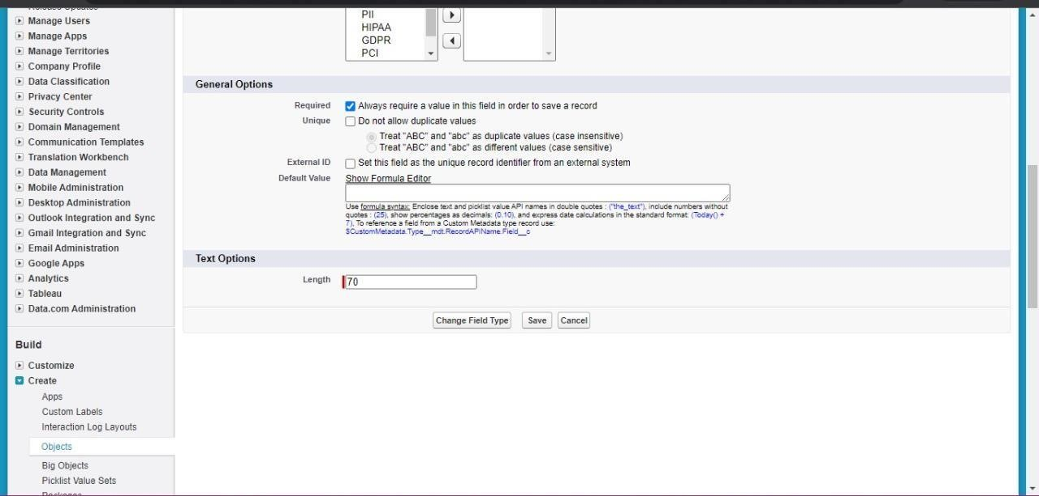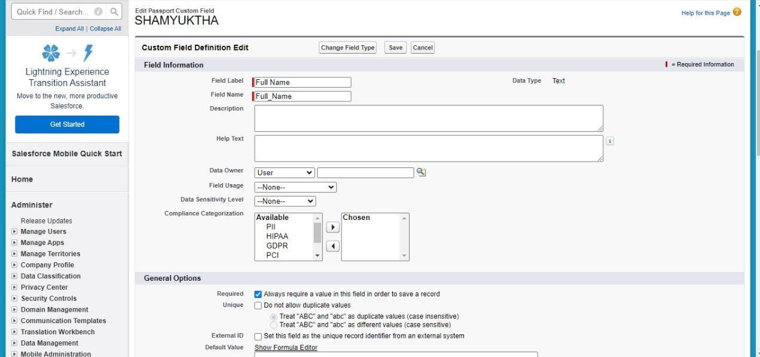

**3)Field Creation: Contact Number:**

1.Navigate to Setup

1. Click the Object Manager next to Home Tab
2. Type Passport in Quick Find and Select it
3. Click on Fields and Relationships
4. Click New
5. Select Data Type: Number, click on next
6. Field Label: Contact Number
7. Length:
8. Next, Save

10 and Decimal 0, click on next

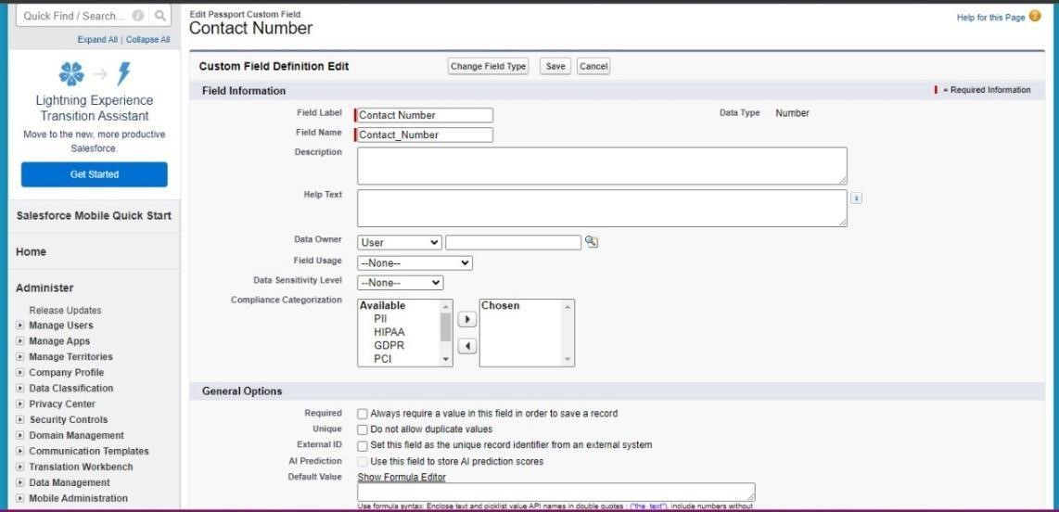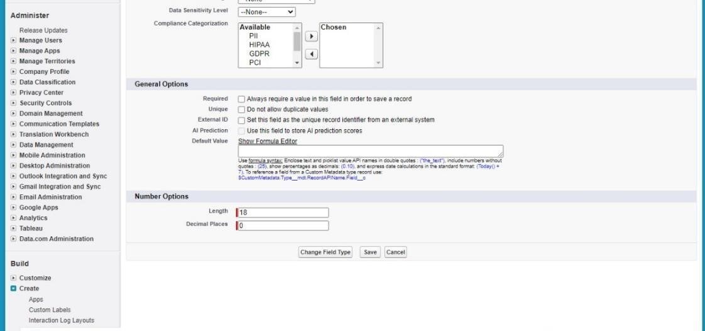

**4)Field Creation: Permanent Address**

1.Navigate to Setup

1. Click the Object Manager next to Home Tab
2. Type Passport in Quick Find and Select it
3. Click on Fields and Relationships
4. Click New
5. Select Data Type: Text Area, click on next
6. Field Label: Permanent Address
7. Next, next and save

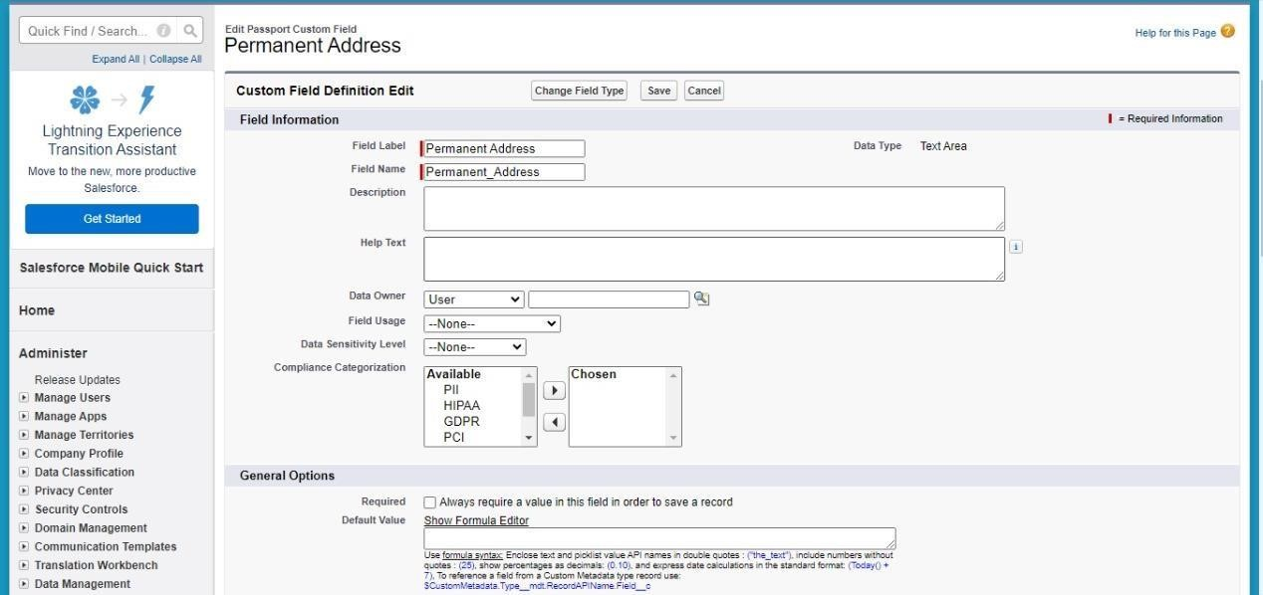

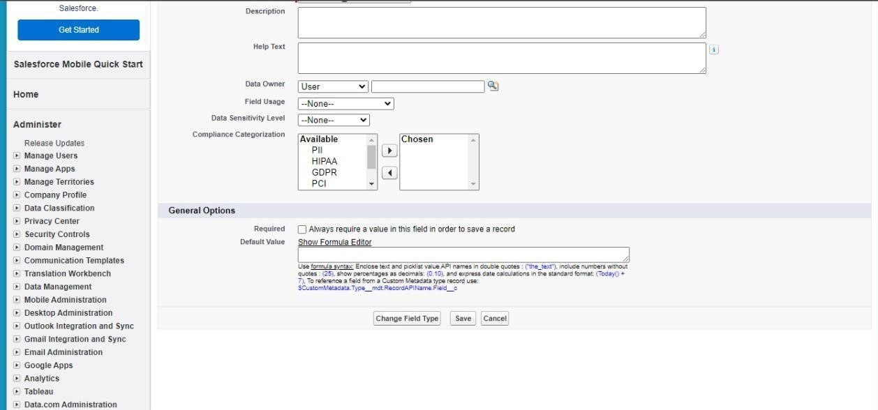

**5)Fields Available On Custom Object: Visa Slot Field Name Data Type**

Location Text

Time Date & Time

Visa Slot Number Auto Number (Use in Record

Name)

Passport Number Master-Detail

Status Picklist

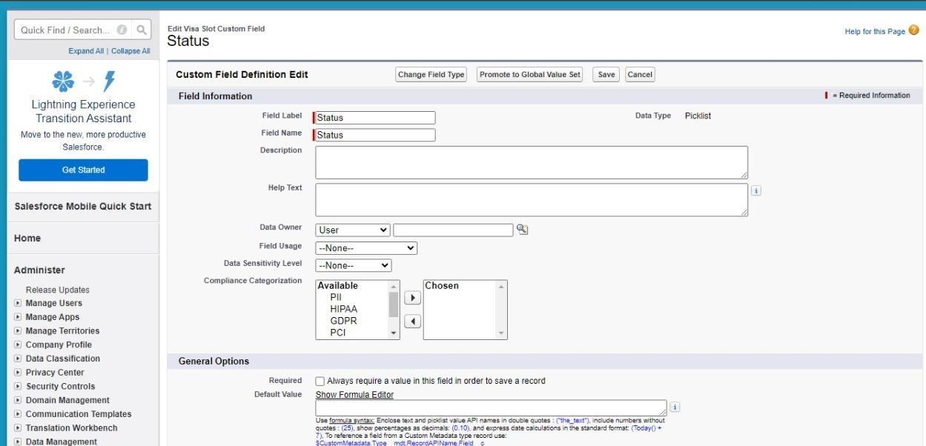

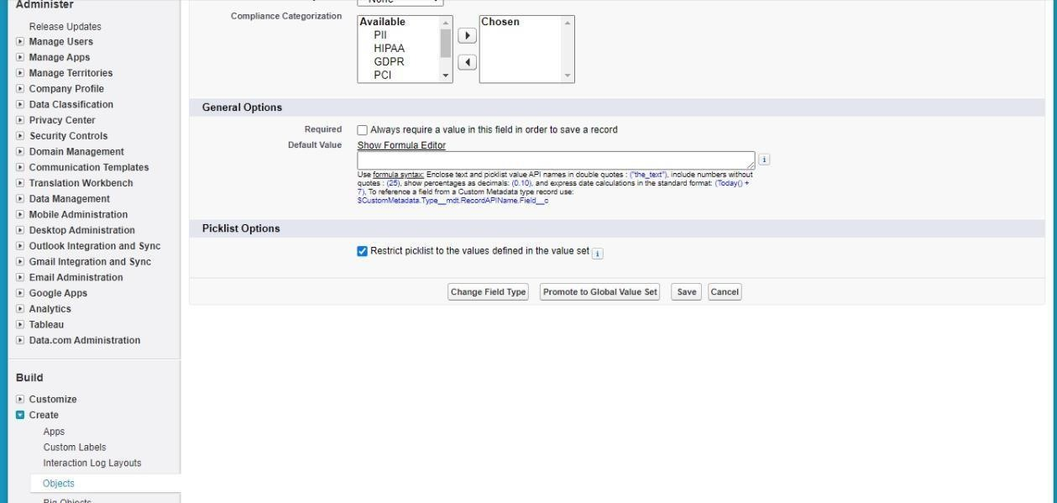

**6)Fields Available On Custom Object: Payment**

Field Name Data Type

Payment Mode Picklist (Values- Debit Card, Credit Card) Card

Number Number

Transaction Id Auto Number (Used in Record Name) Visa Slot Number Master-Detail

Cancel Transaction Text

**Apps:**

Apps in Salesforce are a group of tabs that help the application function by working together as a unit. It has a name, a logo, and a particular set of tabs. The simplest app usually has just two tabs.

There are two types of Salesforce Applications:

1. Standard Apps
2. Custom Apps

**1)Creation Of App:**

Click on setup and go to home page.

1. In Quick Find Box search and select App Manager.
2. Click: New Lightning App.
3. App Name: Book My Visa and click on next.
4. Navigate System: Standard Navigation Support

Form Factor: Desktop and Phone Click next, next

1. Move Objects from available items to selected items. (Passport, Visa Slot, Payment).
2. Add System Administrator profile, available profile to selected profile.

Save & Finish

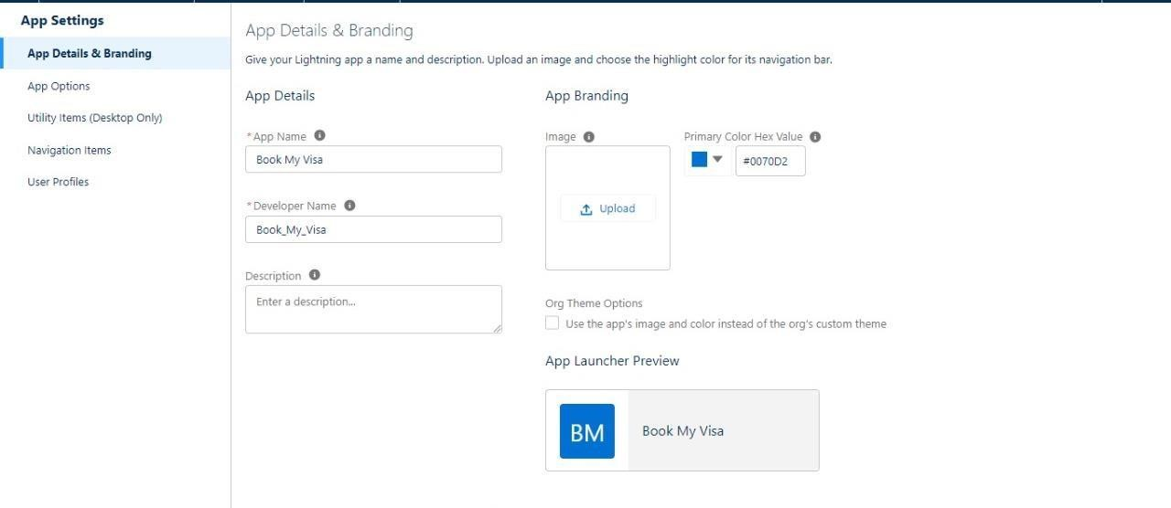

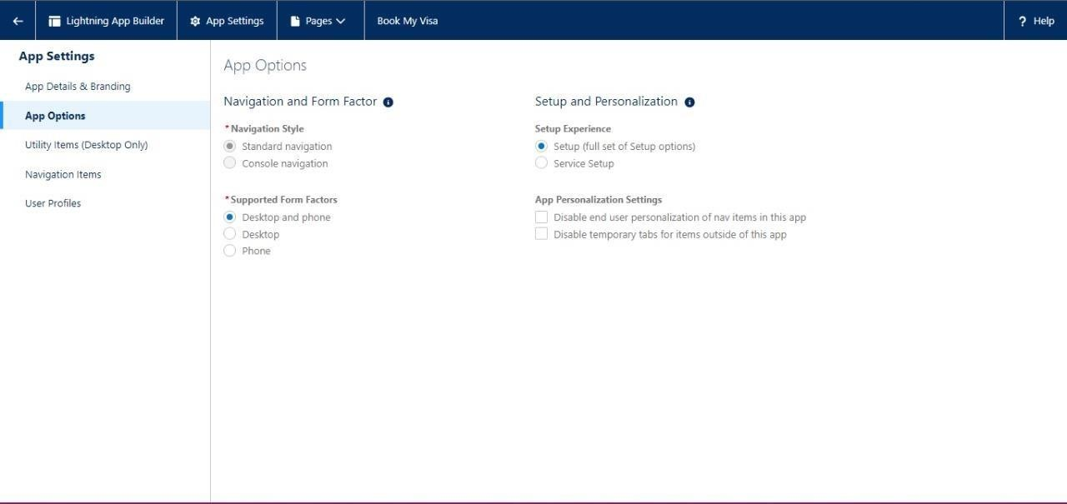

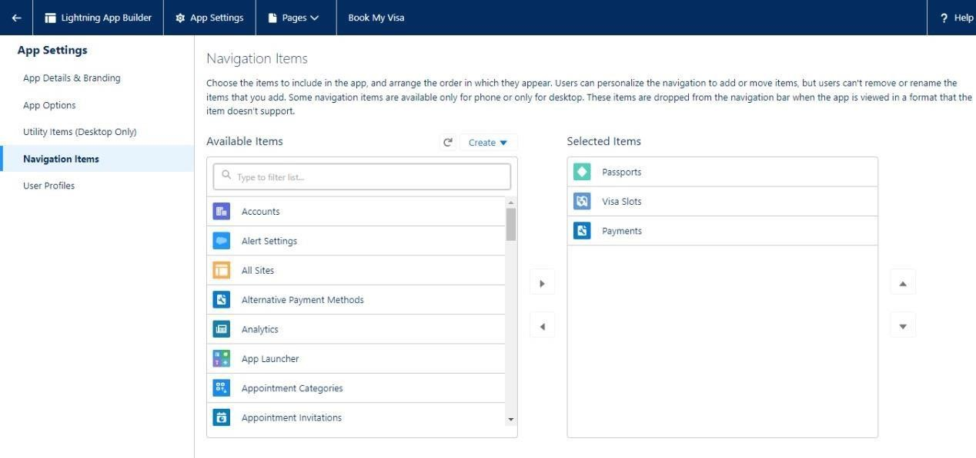

**User:**

A user is anyone who logs in to Salesforce. Users are employees at your company, such as sales reps, managers, and IT specialists, who need access to the company's records. Every user in Salesforce has a user account.

NOTE- As Salesforce license can only be used by 2 Users at a time in Dev Org, so If you don’t find Salesforce license then deactivate a user who has Salesforce license or change the license type from Salesforce to any other

**1)Creation Of User:**

Navigate to setup

1. In Quick Find box select and search: User
2. Click: New user
3. Give First and Last Name
4. Enter your email in the email field
5. Enter user name, it must be unique
6. User license: salesforce platform
7. In the profile field: Standard user profile
8. Check, Generate new password and notify user immediately
9. Save

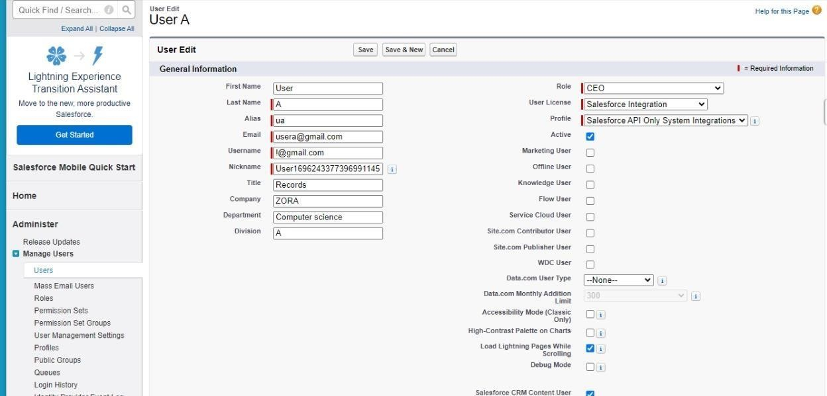

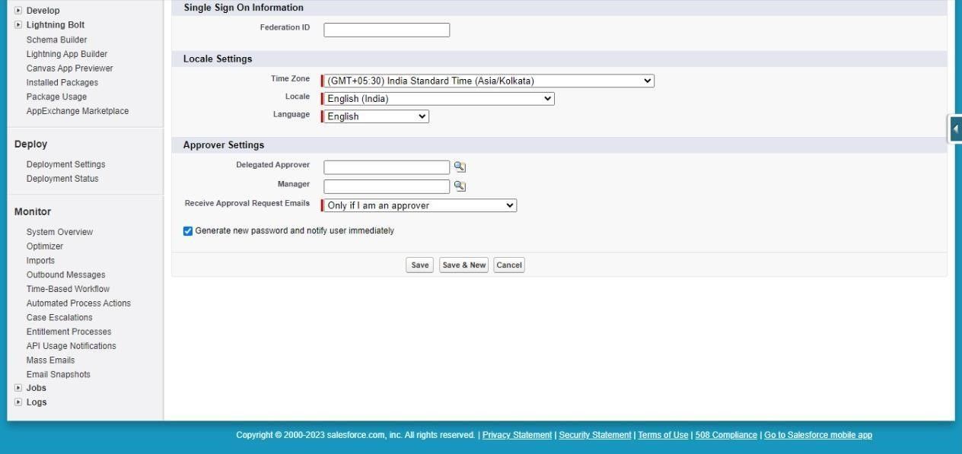

**OWD: Organization Wide Defaults Settings:**

OWD settings determine the baseline level of access for all records of an object. This can be used to give permission to the organization wide and it can be used for restrict the access; we can control the record level access.

OWD can never grant users more access than they have through their object permission.

Primarily four types of access can be set in Salesforce OWD- 1. Public read/write/transfer (Only available for Leads and Cases)

1. Public read/write
2. Public read only
3. Private

Steps of OWD settings:

Navigate setup in Quick Find search bar

1. Type Sharing Setting and Select it.
2. Edit: Organization Wide Defaults.
3. Scroll down list and select Passport…

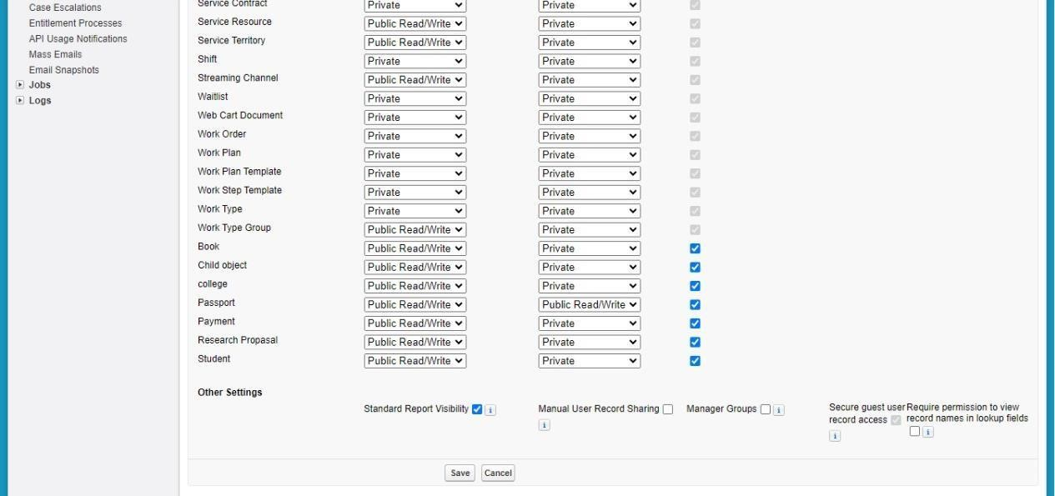

**User Adoption:**

This milestone explains about user adoption **1)Create Record (Passport):**

1.Click on App Launcher on left side of screen.

1. Search Book My Visa App & click on it.
2. Click on Passport tab.
3. Click new button
4. Fill all Passport record details.
5. Click on Save Button.

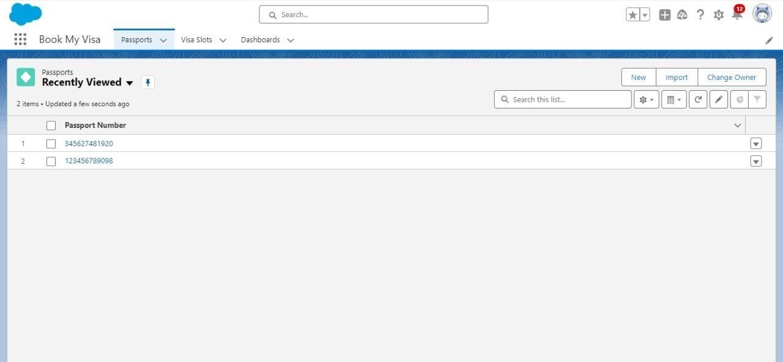

**2)View Records (Passport):**

1.Click on App Launcher on left side of screen.

1. Search Book My Visa & click on it.
2. Click on Passport Tab.
3. Click on any record name. you can see the details of the Driver

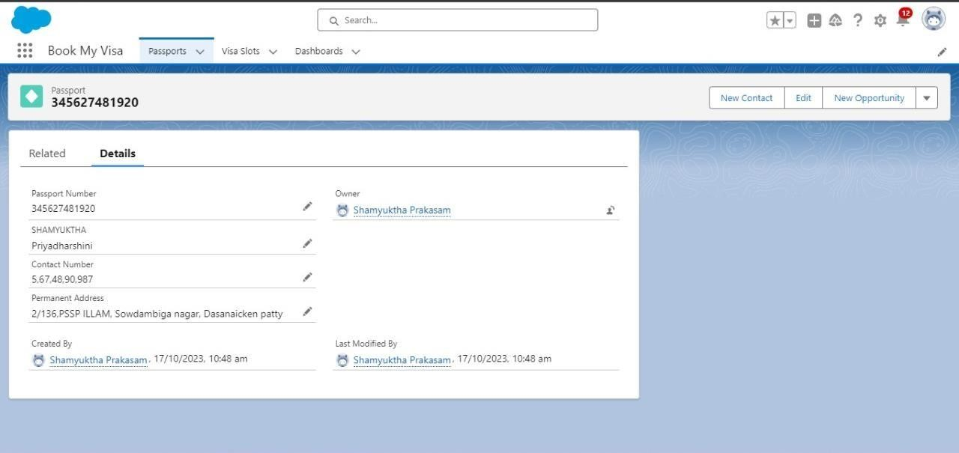

**3)Delete Records (Passport):**

1. Click on App Launcher on left side of screen.
2. Search Book My Visa & click on it.
3. Click on Passport Tab.
4. Click on Arrow at right hand side on that Particular record.
5. Click delete and delete again

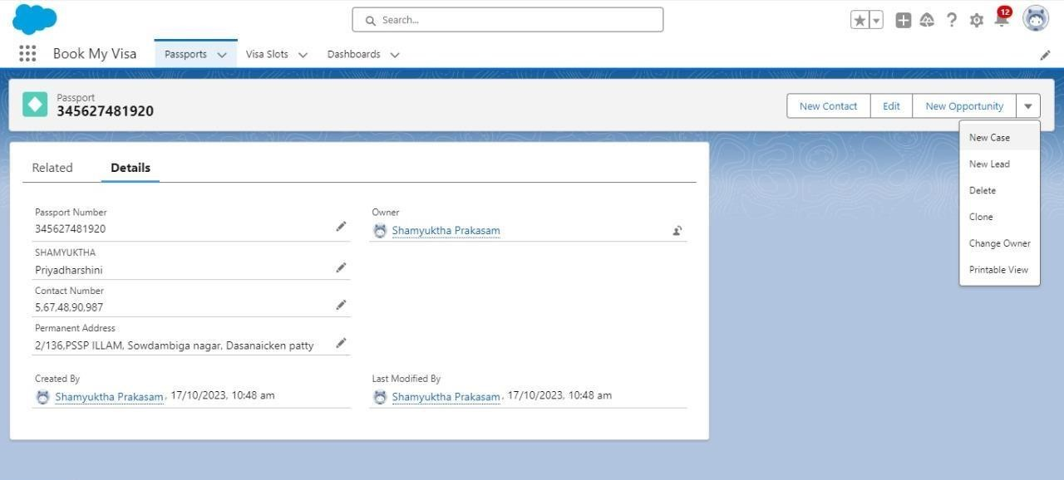

**What Are Reports?**

Reports in Salesforce is a list of records that meet a particular criterion which gives an answer to a particular question. These records are displayed as a table that can be filtered or grouped based on any field.

There are 4 types of report formats in Salesforce: 1.

Tabular Reports:

This is the most basic report format. It just displays the row of records in a table with a grand total. While easy to set up they can’t be used to create groups of data or charts and also cannot be used in Dashboards. They are mainly used to generate a simple list or a list with a grand total.

1. Summary Reports:

It is the most commonly used type of report. It allows grouping of rows of data, view subtotal, and create charts.

1. Matrix Report:

It is the most complex report format. Matrix report summarizes information in a grid format. It allows records to be grouped by both columns and rows. It can also be used to generate dashboards. Charts can be added to this type of report.

1. Joined Reports:

These types of reports let us create different views of data from multiple report types. The data is joined reports are organized in blocks. Each block acts as a sub report with its own fields, columns, sorting, and filtering. They are used to group and show data from multiple report types in different views.

Report Type:

Report type determines which set of records will be available in a report. Every report is based on a particular report type. The report type is selected first when we create a report. Every report type has a primary object and one or more related objects. All these objects mustbe linked together either directly or indirectly.

1.A report type cannot include more than 4 objects.

2.Once a report is created its report type cannot be changed.

There are 2 types of report types:

1. Standard Report Types:

Standard Report Types are automatically included with standard objects and also with custom objects where “Allow Reports” is checked.

Standard report types cannot be customized and automatically include standard and custom fields for each object within the report type. Standard report types get created when an object is created, also when a relationship is created.

Note: Standard report types always have inner joins.

1. Custom Report Types:

Custom report types are reporting templates created to streamline the reporting process. Custom Reports are created by an administrator or

User with “Manage

**Custom:**

Report Types” permission. Custom report types are created when standard report types cannot specify which records will be available on reports.

In custom report types we can specify objects which will be available in a particular report. The primary object must have a relationship with other objects present in a report type either directly or indirectly.

There are 3 types of access levels of folders:

1. Viewer:

With this access level, users can see the data in a report but cannot make any changes exceptcloning it into a new report.

1. Editor:

With this access level, users can view and modify the reports it contains and can also move them to/from any other folders they have access level as Editor or Manager.

1. Manager:

With this access level, users can do everything Viewers & Editors can do, plus they can also control other user’s access levels to this folder. Also, users with Manager Access levels can delete the report. **1)Creation of report:**

Note- While creation of report ensures that update preview automatically is selected which is available at the right side of the report page.

1. Click on App Launcher left side on the screen, Search and select: Report
2. Click Report- select New Report
3. Select Report Type: Passport with Visa Slot Number
4. Click on Start Report button
5. Below the Outline pane- In the Group Row select: Location
6. In Group Column select- Passport: Passport Number
7. In Column select: Visa Slot Number
8. Now navigate to Filter pane available next to Outline pane And ensure in the show me section: All Passport is selected
9. In Passport Created date: All Time.
10. Give the Label: Passport with Visa Location
11. Save & Run for saving the Report, Save.

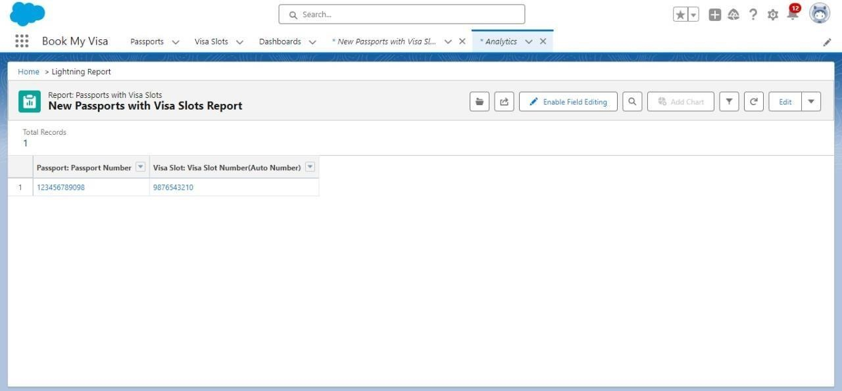

**View Report:**

**1)View Report:**

1. Click on App Launcher on left side of screen.
2. Search Book My Visa App & click on it.
3. Click on Reports Tab.
4. Click on Passport with Visa Location and see reports

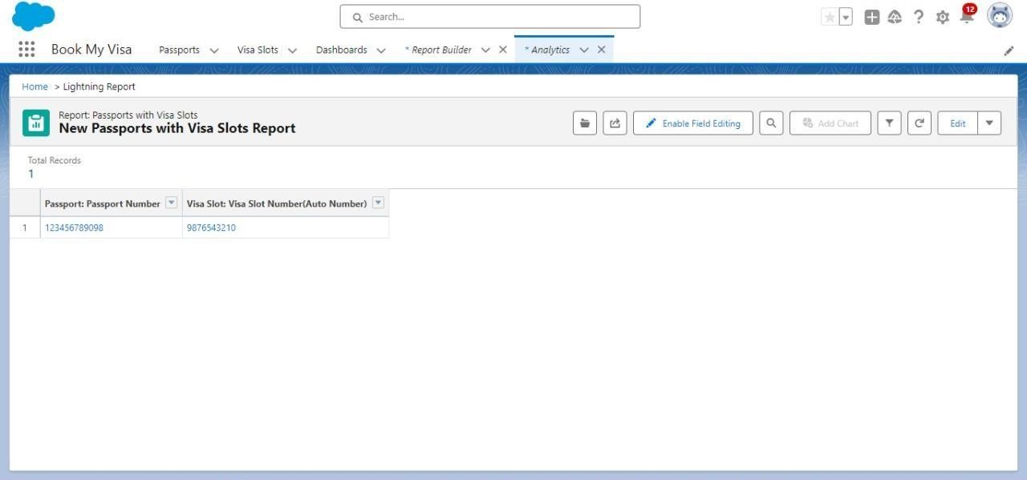

**Dashboards:**

Dashboards in Salesforce are a graphical representation of Reports. It shows data from source reports as visual components. These components provide snapshots of key metrics and performance indicators of the organization at a glimpse. Reports can be displayed in the dashboard like: Horizontal Bar chart, Vertical Bar Chart, Line Chat, Donut Chart, Metric Chart, Stacked Vertical Bar Chart, Stacked Horizontal Bar Chart, etc.

**1)Creation Of Dashboard**

1. Click on the App launcher left on screen and search for dashboards.
2. Select New Dashboard
3. Name the Dashboard: Passport With Visa Location
4. Select Create option
5. Click on Add Component
6. Select Passport with Visa Locations
7. Click Select
8. Select the Donut Chart to display a section
9. Value: Record count
10. Sliced By: Location
11. Leave the default values
12. Click on Add
13. Save the Dashboard and Done

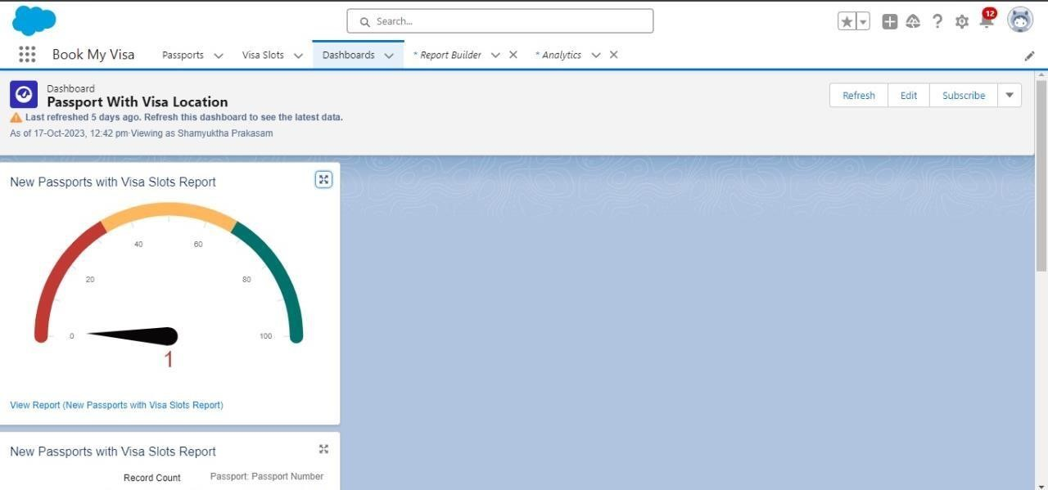

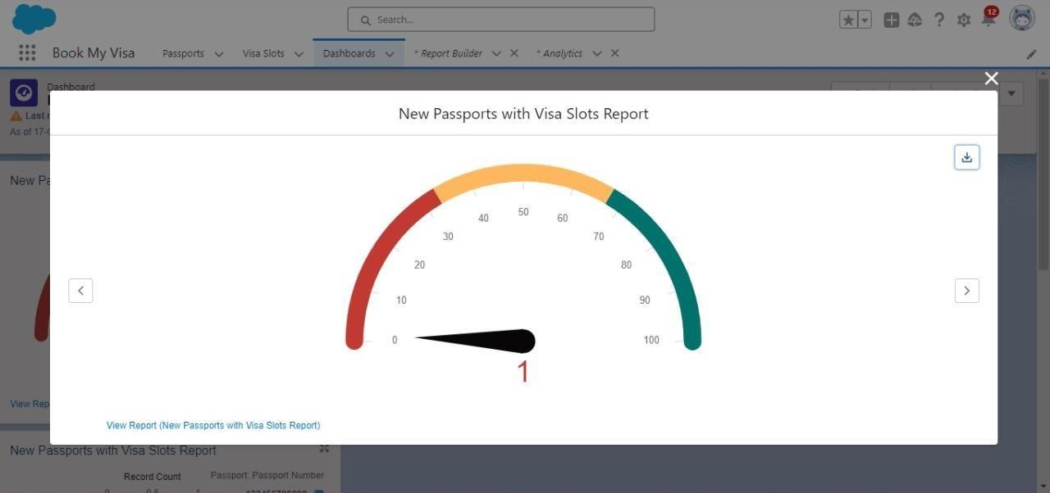

**2)View Dashboard:**

1. Click on App Launcher on left side of screen.
2. Search Book My Visa & click on it.
3. Click on Dashboard Tab.
4. Click on Passport with Visa Location see graph view of records

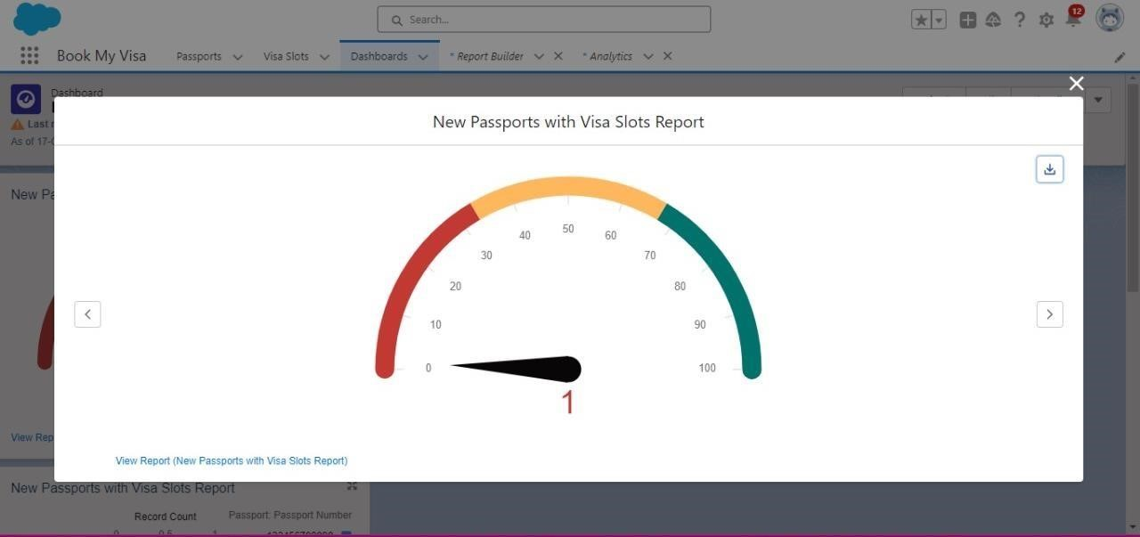

**APEX:**

Apex is a coding language of Salesforce. It can be invoked or started using triggers. A trigger is a set of Apex code that runs before or after data manipulation language (DML) events.

With Apex triggers, you can automate tasks that would otherwise be nearly impossible to accomplish using only the Salesforce user interface. Triggers enable you to create custom scripts that you can implement according to your needs, and the only limitation is your coding skills.

There are two Salesforce Apex trigger types:

Before triggers. These are helpful in cases that require a validation process before accepting a change. They run before any database changes.

After triggers. These are helpful in cases where you need to modify your database records and when the necessary value is stored in other records. They run after any database changes.

**1)APEX:**

1. Click on Set up Gear at drop down list you can find developer console click on that.
2. At the left side top you can find the option new click on that and then apex trigger.
3. Give the name as Deletionofvisarecord
4. And S object has Visa Object
5. Scenario - You cannot delete active visa record

trigger Deletionifvisarecord on Visa_Slot__c (before delete) {

List<Visa_Slot_c> ApprovedVisa = [SELECT Id, Statusc FROM

Visa_Slotc WHERE Id IN :Trigger.old AND Status_c = 'Approved'];

for (Visa_Slot__c Visa : ApprovedVisa) {

Visa.addError('Cannot delete an active Visa.');

}

}

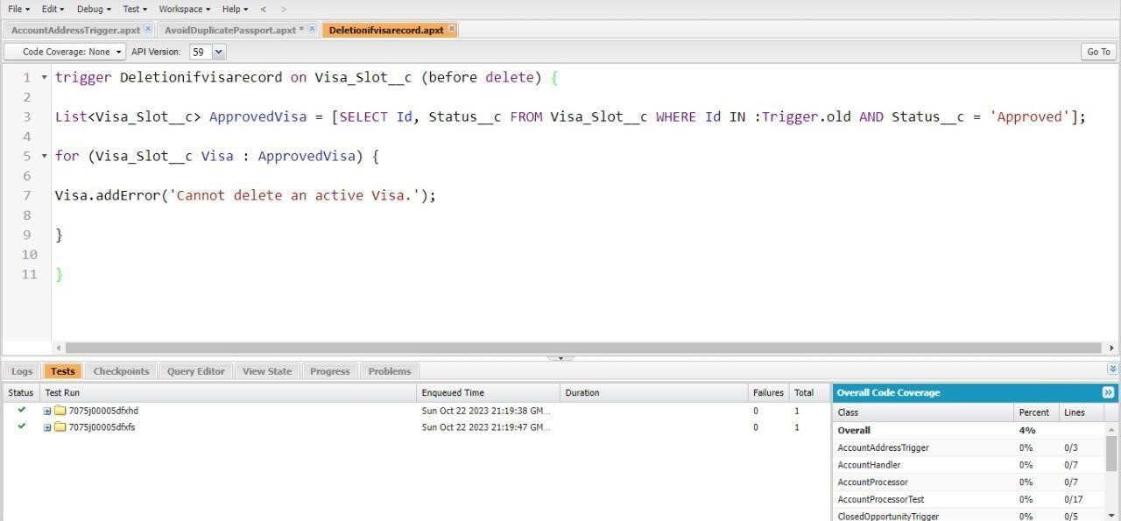

**2)APEX** **:**

1. Click on Set up Gear at drop down list you can find developer console click on that.
2. At the left side top you can find the option new click on that and then apex trigger.
3. Give the name as AvoidDuplicatePassport
4. And S object has Passport Object
5. Scenario - trigger on the Passport_c object to avoid duplicate records based on the Full Name and Contact Number fields. trigger AvoidDuplicatePassports on Passport_c (before insert, before update) {

Set<String> uniqueKeys = new Set<String>();

List<Passport_c> duplicatePassports = new List<Passport_c>(); for

(Passport__c passport : Trigger.new) {

String key = passport.Full_Name_c + '' + passport.Contact_Number__c;

if (uniqueKeys.contains(key)) { duplicatePassports.add(passport);

} else { uniqueKeys.add(key);

}

} for (Passport__c passport : duplicatePassports)

{

passport.addError('Duplicate record found based on Full Name and Contact Number.');

}

}

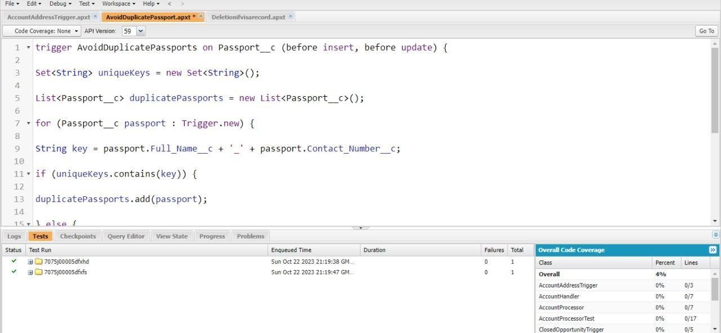

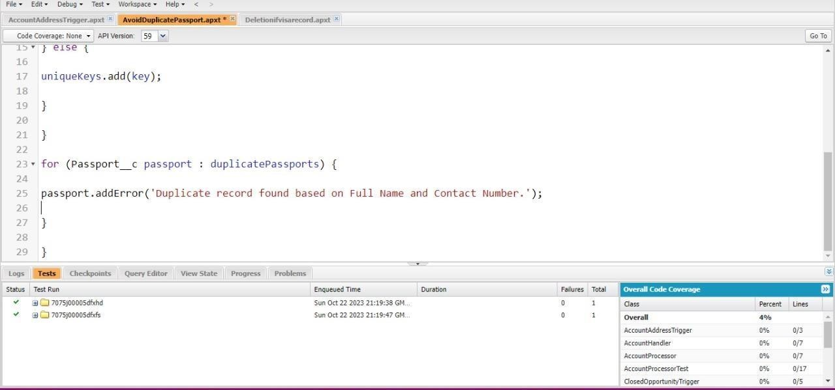

**GitHub&project Video doma Link**

**1.GitHub Link :** https://github.com/Kavi611420/Naan-Mudhalvan-SFD--NM2023TMID01223-MECW

**2.demo link:** [**https://youtu.be/x1PR8LfdVKs?si=FJMCVotKw-j2JGKO**](https://youtu.be/x1PR8LfdVKs?si=FJMCVotKw-j2JGKO)